Strength of soil silt aggregates. Measurements and Discrete Element Method modeling

Horabik J. Józefaciuk G.
Institute of Agrophysics, Polish Academy of Sciences
Doświadczalna 4, 20-290 Lublin, Poland

Corresponding author: Horabik J., e-mail: j.horabik@ipan.lublin.pl
Keywords: soil silt aggregates, strength, discrete element method

Soil aggregates strength, structure and stability have a significant impact on agricultural and geotechnical outcomes. Purpose of this study was to model mechanical strength of the simples case: aggregates artificially formed from silt fraction of soil and ground kaolinite. Cylindrical aggregates of 10 mm in diameter and 20 mm height were formed from homogenized water-saturated pastes made from mixtures of silt and kaolinite in different proportion of components and dried at laboratory conditions. Strength of agglomerates was determined in an uniaxial compression test and modeled via DEM simulation.
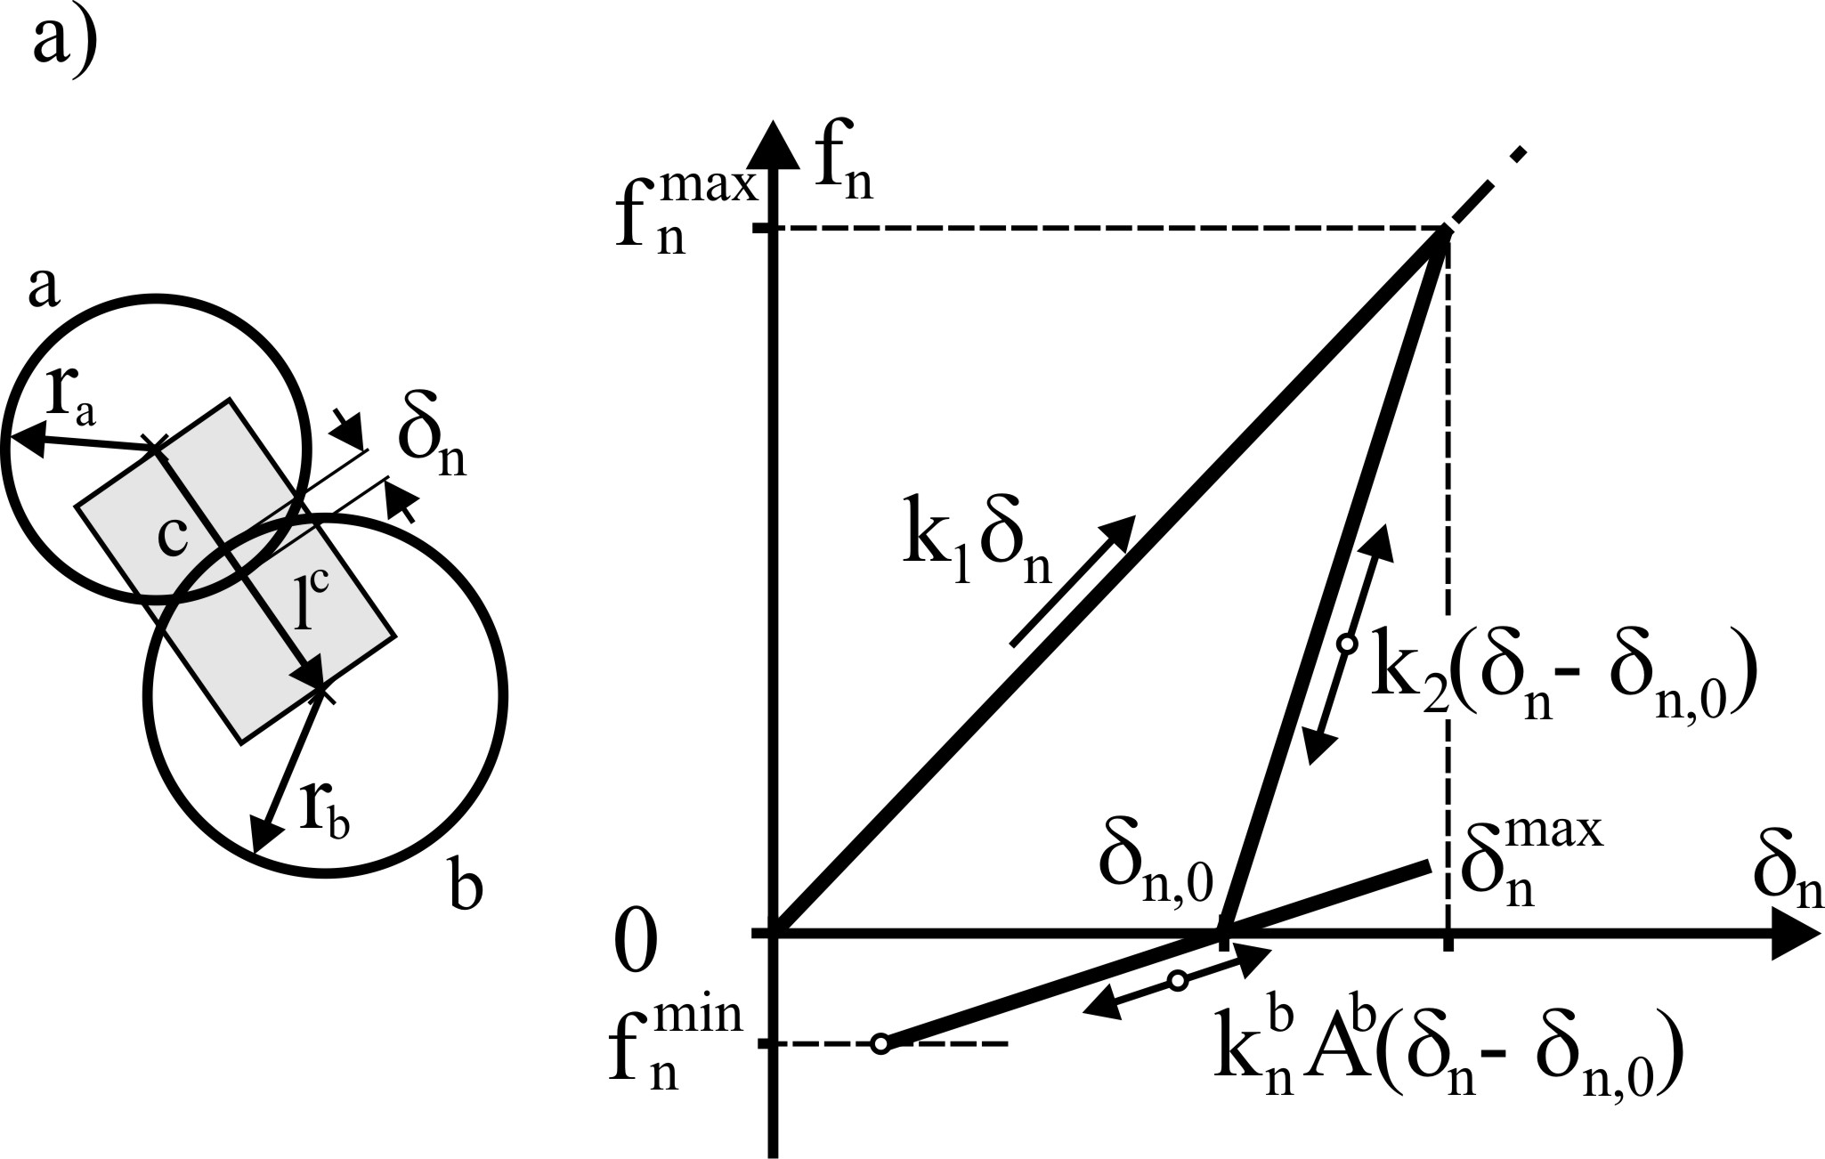 | 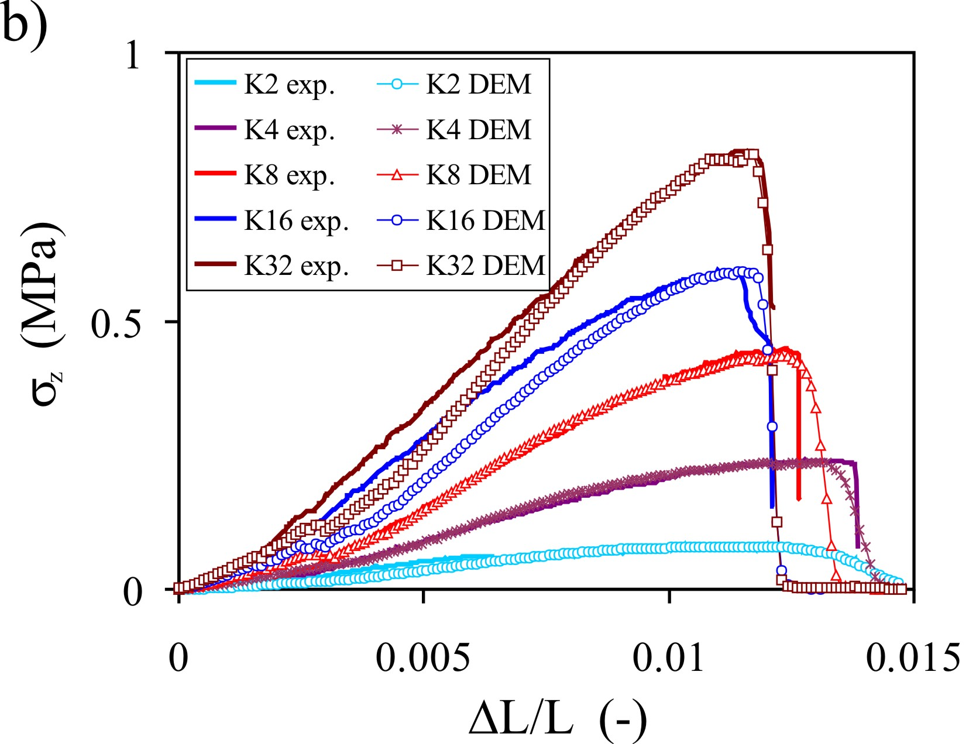
Fig. 1. a) Contact model, b) Experimental and DEM simulated stress-strain response on uniaxial compression.
Soil aggregates revealed a semi-brittle breakage mode. Mechanical strength of aggregates increased almost linearly with the kaolinite concentration up to 32%, i.e. up to filling all macro-pores between sand particles. Young’s modulus of agglomerates increased slower than linearly with kaolinite dose increase up to approximately 170 MPa for sample composed of 100% of kaolinite.
DEM simulations were performed with use of the linear hysteretic contact model and the parallel bonds (Fig. 1a) [1,2]. Simulations reproduced well the stress-strain relationship during the uniaxial compression test (Fig. 1b) and allowed for deeper insight into mechanism of soil aggregates breakage and searching for relationships between micro- and macro-variables. Young’s modulus and compressive strength of agglomerates determined in this study were comparable with values applied by researchers to model interactions between soil agglomerates [3].
References:
- Cundall P.A., Strack O.D. 1979. A discrete element model for granular assemblies. Géotechnique 29, 47–65.
- Potyondy D.O., Cundall P.A. 2004. A bonded-particle model for rock. Int. J. Rock Mech. Min. Sci. 41, 1329–1364.
- Kotrocz K., Mouazen A.M., Kerényi G. 2016. Numerical simulation of soil–cone penetrometer interaction using discrete element method. Comput. Electron. Agr. 125, 63–73.

